**Bug 1:** [pickaboo] Entering comma between alphabets for first name and last name.

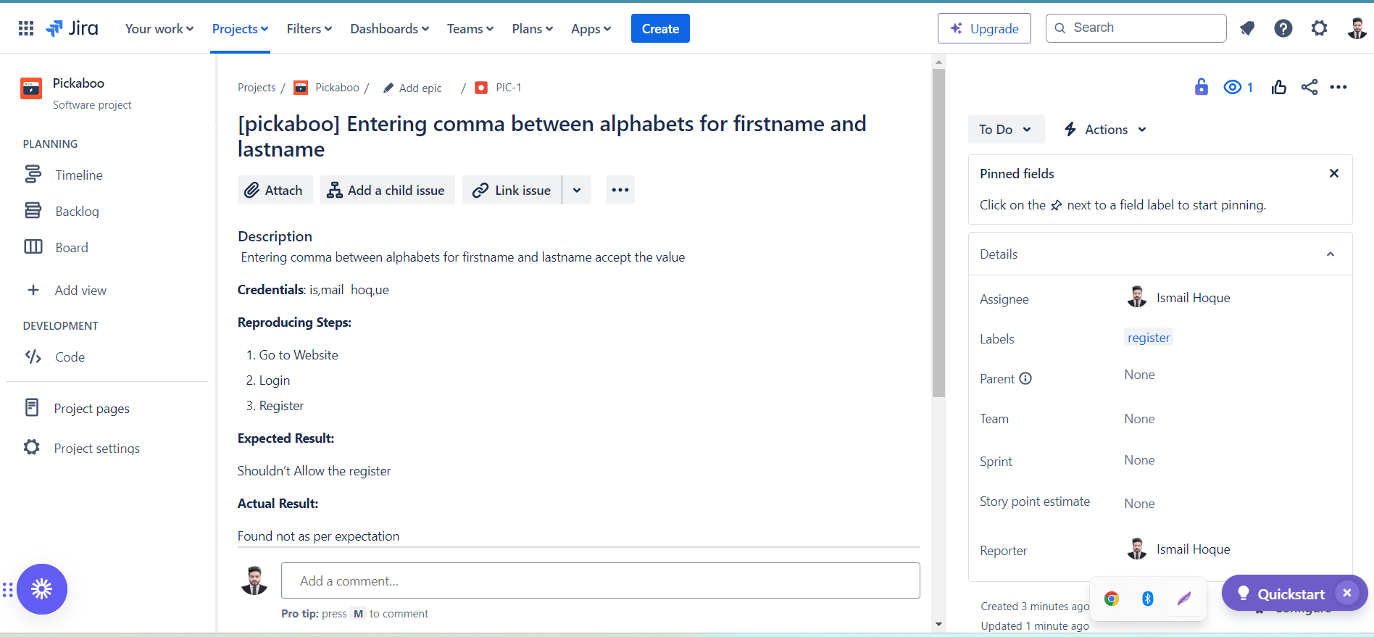

### **Bug 2**: [pickaboo] There have no Remember me checkbox in the Login Page.

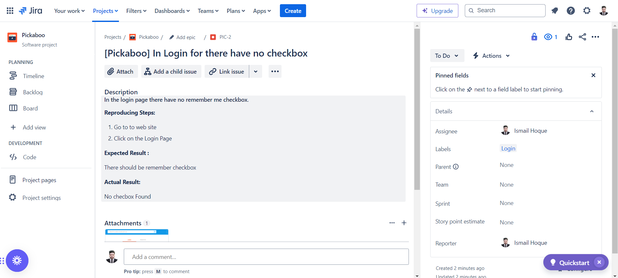

### 

### **Bug 3**: [pickaboo] Special Charachter Error for first and Last name

